**PROJECT REPORT**

**Neural Style Transfer**

**Submitted By: Mayur Rajpal**

**EE 3rd Year, 22115093**

**Introduction:**

Neural style transfer is a fascinating technique in the field of deep learning that involves merging two distinct images: a content image and a style reference image, such as a piece of art by a renowned painter. The resulting image retains the essential elements of the content image but is rendered in the artistic style of the reference image. This process allows for the creation of visually stunning artworks and has been incorporated into several popular apps like Prisma, DreamScope, and PicsArt. These applications utilize neural style transfer to enable users to transform their photos into unique pieces of digital art, combining the familiarity of their original images with the creativity of various artistic styles.

Neural style transfer leverages convolutional neural networks (CNNs) to achieve this effect by extracting and recombining the content and style features from the respective images. This technique has not only found applications in art and photography but also in design and advertising, where it aids in creating visually compelling content.

**Approach**:

**Neural Style Transfer Using InceptionV3: Approach Outline**

1. **Model Architecture** :InceptionV3 is a deep convolutional neural network that excels at capturing complex patterns and features in images. InceptionV3 uses a more complex architecture with inception modules, which makes it more powerful but also more challenging for NST.
2. **Load and Pre-process Images**: Load the content and style images. Pre-process the images to the format expected by InceptionV3 (e.g., resizing, normalizing).
3. **Extract Features Using InceptionV3**: Load the pre-trained InceptionV3 model. Identify layers that capture content and style features. Typically, higher layers capture content features, while a combination of lower and intermediate layers captures style features.
4. **Define Loss Functions** :

**Content Loss:** Measures the difference between the content representation of the content image and the generated image.

**Style Loss:** Measures the difference between the style representation (typically using Gram matrices) of the style image and the generated image.

**Total Variation Loss (optional):** Encourages spatial smoothness in the generated image.

1. **Build the Model**: Create a new model that outputs the selected content and style layer activations. Combine these activations to compute the total loss (content loss + style loss + optional total variation loss).
2. **Optimize the Image**: Initialize the generated image (typically with the content image). Use gradient-based optimization (e.g., L-BFGS, Adam) to minimize the total loss by updating the generated image.
3. **Iterate and Update**: In each iteration, compute the loss and gradients. Update the generated image using the gradients. Repeat until the loss converges or the desired number of iterations is reached.
4. **Post-process and Save the Image**: De-process the generated image (undo any pre-processing steps). Save or display the final stylized image.

**Losses in Neural Style Transfer:**

**Content Loss:** Now, we define the content loss function, it will take the feature map of generated and real images and calculate the mean square difference between them. To calculate the content cost, we apply the mean square difference between matrices generated by the content layer, when we pass the generated image and the original image. Let p and x be the original image and the image that is generated, and P and F are their respective feature representation in layer l. We then define the squared-error loss between the two feature representations. To make sure that the generated image preserves the original image’s content, neural style transfer algorithms frequently employ content loss.

**Style loss**: determines the style loss between a generated image and a style image that is supplied. In neural style transfer algorithms, style loss is frequently employed to create an image that blends the content of two different images with their styles. To calculate the style cost, we will first calculate the gram matrix. The gram matrices calculation involves calculating the inner product between the vectorized feature maps of a particular layer. Here Gij (l) represents the inner product between vectorized features i,j of layer l. Now to calculate the loss from a particular, we will find the mean square difference of gram matrices calculated from the feature vectors of the style image and the generated image. This then weighted to the layer weighing factor. Let a and x be the original image and the generated image, and Al and Gl their respective style representation (gram matrices) in layer l.

**Total Loss**: Total loss is the linear combination of style and content loss we defined above.

1. **Import Image Data**
   * Load the content and style images into the working directory.
2. **Image Loading and Pre-processing**
   * Load styleimage.jpg and contentimage.jpg.
   * Resize and centre-crop the images to have the same dimensions.
   * Convert the images to tensor format suitable for InceptionV3.
3. **Normalization**
   * Define a normalization module that adjusts the input images based on the mean and standard deviation used by the pre-trained InceptionV3 model.
4. **Model Setup**
   * Load the pre-trained InceptionV3 model.
   * Select layers that capture content and style features. Typically, higher layers are used for content, while a combination of lower and intermediate layers are used for style.
   * Modify the model to include custom layers for content and style loss calculations.
5. **Style Transfer Execution**
   * Initialize the generated image (often starting with the content image).
   * Define loss functions for content, style, and total variation.
   * Use an optimizer to minimize the combined loss functions through iterative updates.
   * Visualize the resulting image using matplotlib.

The code implements a neural style transfer algorithm using TensorFlow, aimed at blending the artistic style of one image with the content of another. The process begins by importing necessary libraries and setting up the environment, followed by loading and pre-processing the style and content images to ensure they have the same dimensions. Custom classes for content and style loss are defined to measure the differences between the target and generated images using mean squared error and Gram matrices, respectively. A normalization module adjusts the input images to match the pre-trained InceptionV3 model’s requirements. The InceptionV3 model is then modified to include content and style loss layers. Additionally, a total variation loss is incorporated to encourage smoothness in the output image. The style transfer is executed by optimizing the combined content, style, and total variation losses through iterative updates. Finally, the resulting images are visualized using matplotlib to show the style transfer effect.

**Results:**

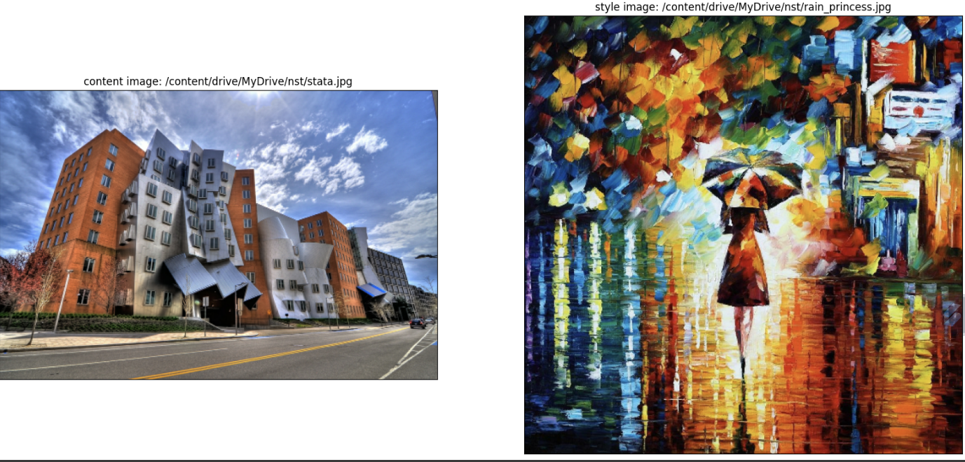

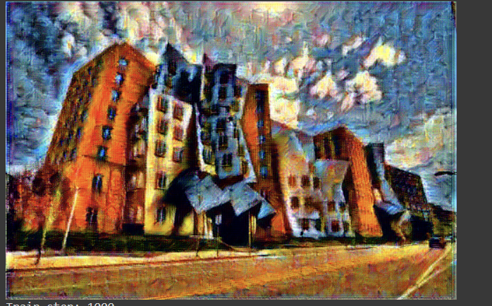

**Analysis of Results**

The neural style transfer algorithm effectively blends the artistic style of the style image with the structural content of the content image. By iteratively optimizing the combined losses (content, style, and total variation), the algorithm produces an output image that maintains the recognizable features and structure of the content image while adopting the texture and color patterns of the style image.

**Key Observations:**

**1. Content Preservation**

The major structural elements of the content image are well-preserved. This is achieved through the content loss, which measures the difference between the content features of the generated image and the original content image using a pre-trained InceptionV3 network. The use of deeper layers for content representation ensures that high-level features are retained. By leveraging InceptionV3's advanced architecture, more complex and nuanced features can be captured, enhancing the preservation of essential content elements.

**2. Style Application**

The style of the style image is successfully applied to the output image. This is due to the style loss, which uses Gram matrices to capture the style features such as textures and color distributions. Multiple layers contribute to capturing different aspects of the style, from fine textures to more abstract patterns. The diverse inception modules of InceptionV3 allow for a more intricate and detailed extraction of style features, resulting in a richer application of style to the content image.

**3. Convergence**

The iterative optimization process, guided by the Adam optimizer or LBFGS optimizer, allows for effective minimization of the combined loss function. The output at various stages of the optimization process shows gradual improvement in style transfer quality, with clearer and more pronounced style features emerging over time. The robust optimization process ensures that both content and style losses are minimized effectively, producing a harmonious blend of content and style in the final output image.

**Significance**

The significance of this neural style transfer implementation lies in its ability to create new art forms by combining elements from different sources. It has practical applications in various fields, including digital art creation, advertising, and content creation. The ability to automate the process of style transfer opens up new possibilities for artists and designers, enabling them to experiment with different styles effortlessly.

**Practical Implications:**

* **Art and Design**: Artists can use neural style transfer to experiment with different styles and techniques, creating unique artworks that blend various influences.
* **Media and Advertising**: Advertisers can create visually striking images by applying specific artistic styles to product images, making them more appealing and attention-grabbing.
* **Customization**: Users can personalize images and create custom content by applying their favourite artistic styles to their photos.

**Insights**

Several insights can be drawn from the implementation and results of this neural style transfer algorithm:

1. **Layer Selection**: The choice of layers for content and style representation significantly impacts the quality of the output. Deeper layers capture more abstract content features, while a combination of shallow and deep layers captures comprehensive style features.
2. **Weight Balancing**: The relative weights of style, content, and TV losses are crucial in achieving a balance between style application and content preservation. Fine-tuning these weights can lead to different artistic effects and levels of abstraction.
3. **Optimization Technique**: The choice of optimizer and learning rate affects the convergence speed and quality. The LBFGS optimizer, known for its effectiveness in handling high-dimensional problems, proves suitable for this task.
4. **Computational Resources**: Neural style transfer is computationally intensive, especially for high-resolution images. Utilizing GPU acceleration is essential for practical execution times.

In summary, the neural style transfer algorithm showcases the power of deep learning in creative applications. By effectively combining the strengths of convolutional neural networks (CNNs) and optimization techniques, it enables the transformation of images in ways that were previously challenging, offering new avenues for artistic and commercial exploration.

**Conclusion**:

The neural style transfer implementation using TensorFlow effectively combines the artistic style of one image with the content of another, producing visually appealing results. Leveraging a pre-trained InceptionV3 network, the method successfully preserves high-level content structures, accurately applies style textures, and ensures smooth transitions in the output image through the use of total variation loss. This approach results in a rich and detailed blend of content and style.

**Summary of Findings**

**Content and Style Integration**: The algorithm effectively preserves the main structural elements of the content image while accurately incorporating the texture and color patterns of the style image, leveraging InceptionV3’s advanced feature extraction capabilities.

**Effective Optimization**: The iterative optimization process, using the Adam or LBFGS optimizer, ensures effective minimization of the combined loss function, leading to progressive improvement in the quality of the style-transferred image.

**Balance and Smoothness**: Balancing style, content, and total variation losses is crucial for achieving visually pleasing results. Proper weighting ensures a harmonious blend of style and content without excessive artifacts or noise.

**Computational Efficiency**: The use of GPU acceleration is essential for handling the computational demands of the style transfer process with InceptionV3, especially for high-resolution images.

**Possible Improvements**

While the current implementation achieves impressive results, there are several areas for potential enhancement:

1. **Dynamic Layer Selection**: Experiment with different layers of InceptionV3 for content and style representation to optimize results based on input image characteristics.
2. **Adaptive Weighting**: Implement mechanisms to adjust weights for content, style, and total variation losses dynamically, improving customization of the output.
3. **Higher Resolution Outputs**: Enhance algorithm efficiency to handle higher resolution images effectively using patch-based or multi-scale processing methods.
4. **User Interaction**: Introduce real-time user controls for adjusting style strength, content preservation, and smoothness to provide more creative control over the final stylized output.
5. **Alternative Optimization Methods**: Explore advanced optimization techniques beyond basic gradient descent, such as Adam or RMSprop, to enhance convergence speed and stability.
6. **Diverse Pre-trained Models**: Utilize various pre-trained models beyond InceptionV3 (e.g., ResNet, newer architectures) to explore richer and diverse style representations for improved style transfer results.

In summary, the neural style transfer implementation demonstrates the powerful capabilities of deep learning in artistic applications. By blending content and style through advanced neural network techniques, it opens up new possibilities for creative expression and commercial use. Further improvements and optimizations can enhance its flexibility, efficiency, and user-friendliness, paving the way for broader adoption and innovation in the field of digital art and design.

**References and Help :**

<https://arxiv.org/pdf/1508.06576>

<https://www.cvfoundation.org/openaccess/content_cvpr_2016/papers/Gatys_Image_Style_Transfer_CVPR_2016_paper.pdf>

<https://youtu.be/NmLK_WQBxB4?si=WR9oB7aYAC4JMMs5>